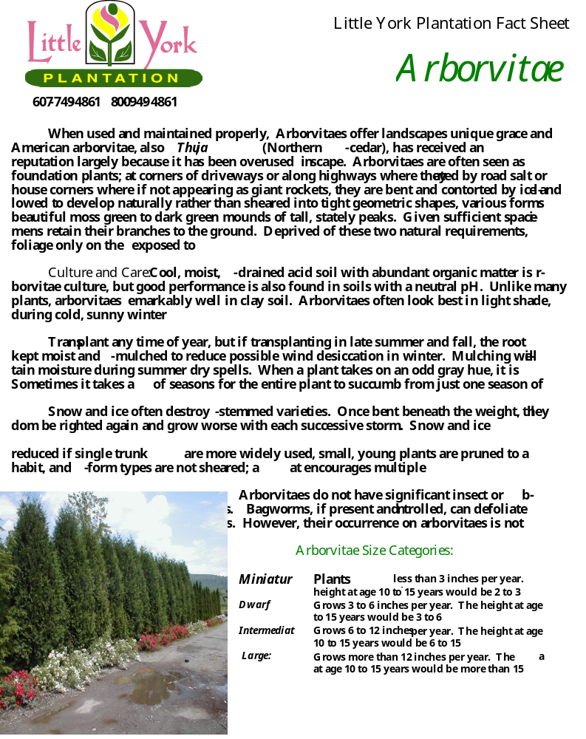

Varieties Recommended and Carried by Little York Plantation:

Thuja occidentalis ‘brandon’: A fast growing, compact, columnar form with dense, bright green summer foliage. A very hardy cultivar. Mature height 12-15 feet.

Thuja occidentalis ‘emerald smaragd’: Emerald green summer color turns yellow-green in winter. It is heat tolerant, slow growing, and can develop multiple trunks. Mature height 10-15 feet.

Thuja occidentalis ‘globosa woodward’: Retains globe shape without trimming; rich green foliage. Mature height 4 feet.

Thuja occidentalis ‘hetz midget’: A slow growing, densely globule selection. Foliage is dark, bluish green turning yellow-green in winter. Excellent in foundation and low border plantings. Mature height 2 feet.

Thuja occidentalis ‘holmstrup’: One of the best dwarf, conical selections that deserves to be used more; a slow grower with narrow form. Summer color is bright green changing to gray-green in winter. Makes an excellent foundation plant, low hedge or accent plant in a mixed border. Mature height 4-5 feet.

Thuja occidentalis ‘little gem’: Grows slowly into a mounding, lumpy habit that becomes slightly conical with age. It is dark green in summer and turns bright yellow-green in winter. Suitable for a foundation or border, it reaches a mature size of 3 feet high and 4 feet wide.

Thuja occidentalis ‘pyramidalis’: A narrow, fast-growing, single-trunked form that grows 25 feet tall and only 5 feet wide. Summer foliage is dark green with lighter tips that be come yellowish-green in winter.

Thuja occidentalis ‘rheingold’: Rounded to broadly conical shape with a mixture of adult and juvenile foliage. Color is gold with yellow-orange highlights. Versatile in the landscape and can be used as an accent, specimen or border plant or mixed with herbaceous plants for wonderful color contrast.

Thuja occidentalis ‘shermanii’ Dark green foliage with heavy, thick appearance. Broad pyramidal shape. Mature height 25-30 feet.

Thuja occidentalis ‘techny’: Grows as an upright, oval tree with a broad base. It is slow growing and makes an excellent screen or hedge. Foliage is dark green year-round. Mature height 12-15 feet.

Thuja occidentalis ‘wareana’: A tough evergreen useful for screens and wind breaks. Habit is conical with a broad base. Mature height 12-15 feet.

Thuja orientalis ‘elegantissima’: Excellent large screen or specimen plant with rapid growth rate,
pyramidal shape and dense texture. Mature height 12-15 feet.

Visit us on the Web! www.littleyorkplantation.com

